Year 3 Homework – Due 11/09/2026
- How many marbles are there?
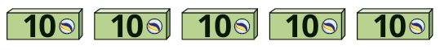 ____________

- Complete the sentences.
There are _________ tens in 50.
There are _________ tens in 100.
There are _________ hundreds in 500.
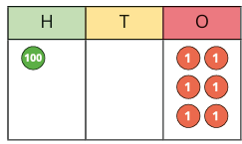
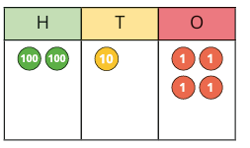
There are ________ tens in 500.
3) What numbers are shown in the place value charts?

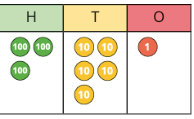
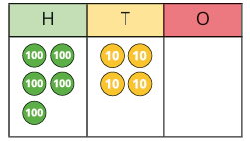

Year 4 Homework – Due 11/09/2026
- How many crayons are there?

____________

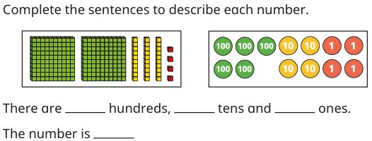
- Complete the sentences to describe each number.

- b)
- There are ______hundreds, ______tens and ______ones.
The number is_______.
- There are ______hundreds, ______tens and ______ones.
The number is_______.

3) What numbers are shown in the place value charts?

