History: A Monarch's Day

What might a king or queen do every day? Tick the correct boxes.

​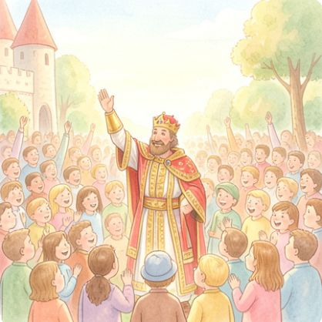  ​  [ ] Wave to the public |  |   ​  [ ] Do the supermarket shopping
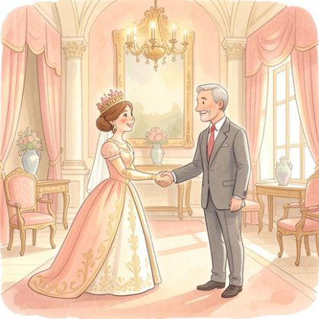  ​  [ ] Meet important people |  |   ​  [ ] Play on a tablet all day
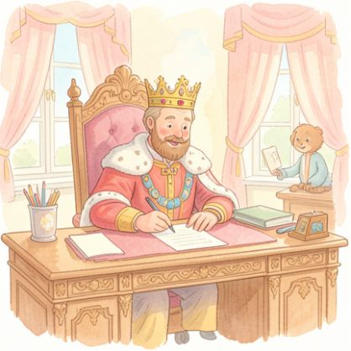  ​  [ ] Sign official papers |  |   ​  [ ] Visit charities and hospitals
​

Draw a picture of a monarch doing one of their important daily jobs.

Write a sentence about what the monarch is doing in your picture.

